Java Development Tools

Installing Java

For Windows
- Download 20 GA Java for Windows: https://jdk.java.net/archive/
- Unzip it into c:\opt\Java
- Set JAVA_HOME as system variable:
Go to your desktop, right-click on the ‘This PC’ icon, and select ‘Properties’ as shown below.
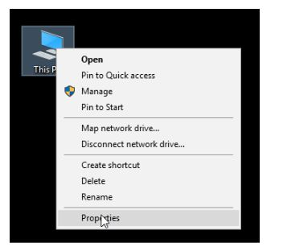
After selecting ‘Properties’, you will enter the system information window that will describe your computer hardware specifications and operating system details. On the left-hand side top corner, you will find a set of options, out of which you need to select ‘Advanced system settings’.
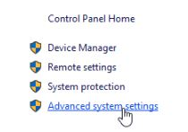
After selecting the ‘Advanced system settings’ option, you will be guided to the next window where you need to choose ‘Environmental variables’, as demonstrated below.
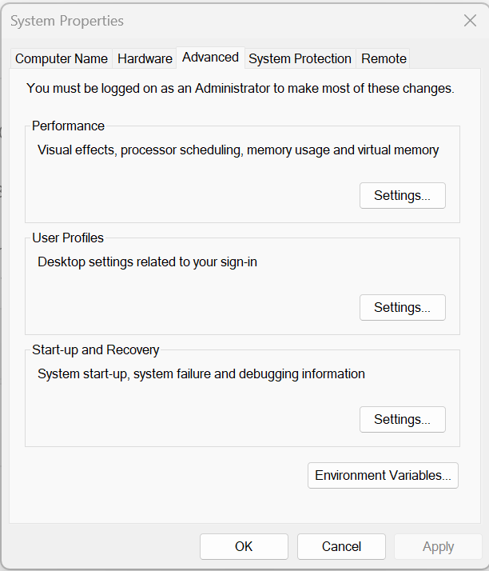
Once you enter the ‘Environment variables’, you will be redirected to the next window where you get to set the JAVA_HOME and JAVA_PATH variables.
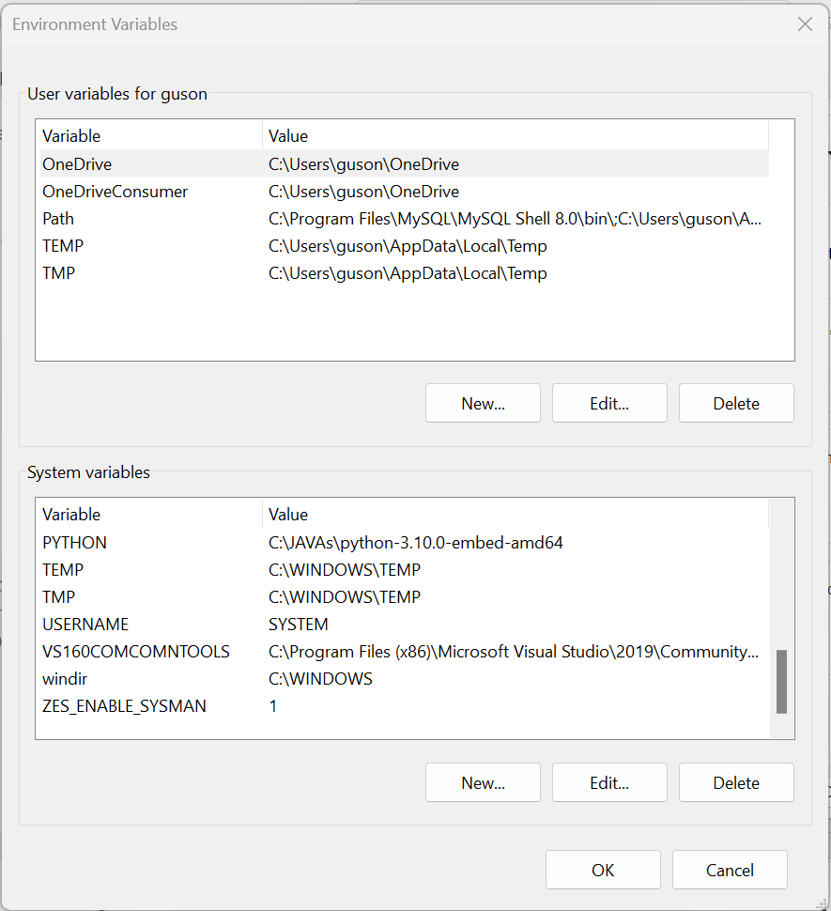
You can see the ‘System variables’ option in the top dialogue box. Select the new option, and you will get another dialogue box where you can set JAVA_HOME and the address of the JDK bin folder, as displayed below.
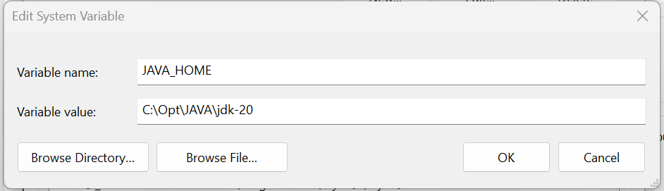
Select ‘OK’, and the JAVA_HOME gets set successfully installed. The next stage involves ‘where to set the JAVA_PATH’. For that, we need to select and edit the ‘Path’ from the Environment Variables window in System Variables Dialogue box, as shown below.
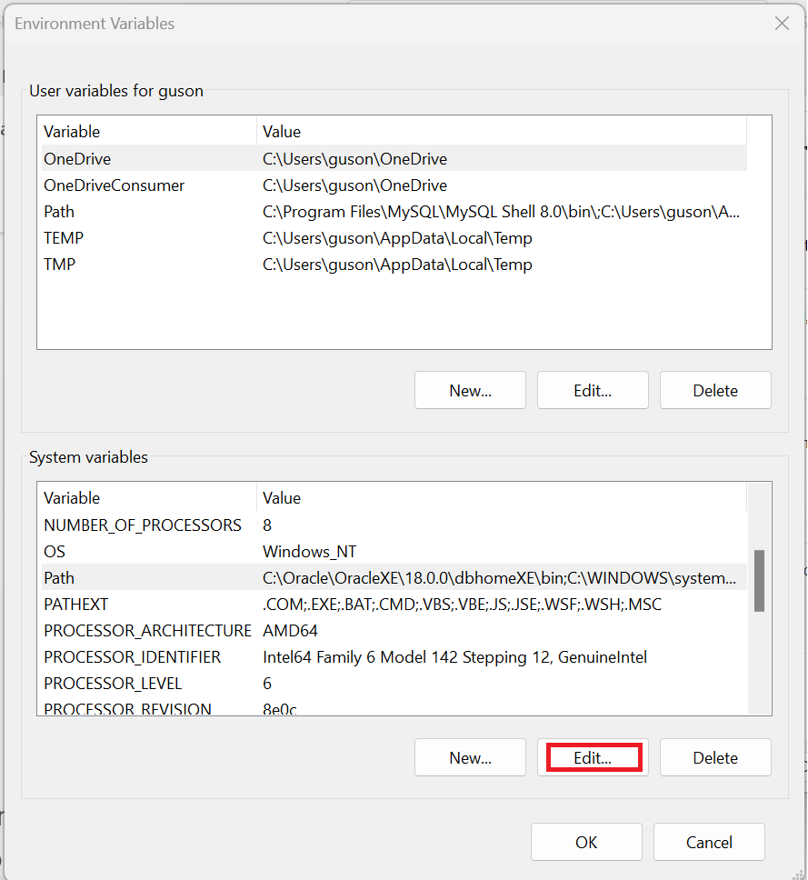
Once you select the edit option, you will enter a new window, where you need to select ‘New’ and add a new JAVA_PATH variable, as shown below.

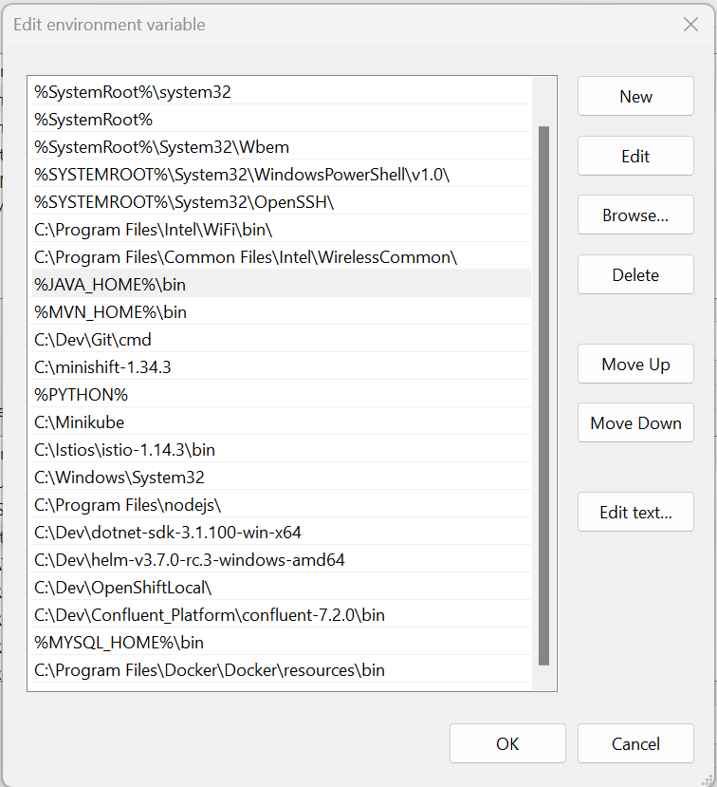
- Next, you can close the environmental variables window by selecting ‘OK’, and both your JAVA_HOME and JAVA_PATH get successfully set.
- Confirm the Java PATH variable was set properly
- Run a JDK command to verify Java install was a success

For Mac
brew install openjdk

Installing Maven

For Mac
brew install maven

For Windows
To install Maven on your own system (computer), go to the Maven download page and follow the instructions there. In summary, what you need to do is:
- Set the JAVA_HOME environment variable to point to a valid Java SDK (e.g. Java 18).
- Download and unzip Maven.
- Set the M2_HOME environment variable to point to the directory you unzipped Maven to.
- Set the M2 environment variable to point to M2_HOME/bin (%M2_HOME%\bin on Windows, $M2_HOME/bin on unix).
- Add M2 to the PATH environment variable (%M2% on Windows, $M2 on unix).
- Open a command prompt and type 'mvn -version' (without quotes) and press enter.
After typing in the mvn -version command you should be able to see Maven execute, and the version number of Maven written out to the command prompt.
Note: Maven uses Java when executing, so you need Java installed too (and the JAVA_HOME environment variable set as explained above). Maven 3.0.5 needs a Java version 1.5 or later. I use Maven 3.3.3 with Java 8 (u45).
I have a tutorial about installing the Java SDK in case you are not familiar with that. Remember, it has to be an SDK (Software Developer Kit), not just a JRE (Java Runtime Environment). The JRE does not contain a Java compiler. Only the SDK does.

Installing Eclipse

For Windows
https://www.eclipse.org/etrice/downloads/
https://www.guru99.com/install-eclipse-java.html

For Mac
brew install --cask eclipse-java

Reference
https://www.vogella.com/tutorials/Eclipse/article.html

